DBMS LAB 9

By: Ishita Bharadwaj

SRN: PES1UG20CS648

Section: K

Roll No: 43

1. Write a trigger on insert to compartment table when a new compartment gets added to a train and make sure that total number of compartments available in the train does not exceed more than 4.

delimiter $$

create trigger comp_check

before insert

on compartment for each row

begin

declare c int;

declare msg varchar(255);

set msg=('Compartments available in train exceeds 4');

if (select count(*)

from compartment

where train_number=new.train_number)>=4 then

SIGNAL sqlstate '45001'

set message_text=msg;

end if;

end$$

delimiter ;

insert into COMPARTMENT (compartment_no,compartment_type,capacity,availability,train_number) values

('F01','III Class','12','8','62621');

insert into COMPARTMENT ((compartment_no,compartment_type,capacity,availability,train_number) values

('F01','I Class','12','8','62620');

insert into COMPARTMENT (compartment_no,compartment_type,capacity,availability,train_number) values

('G01','II Class','5','8','62620');

insert into COMPARTMENT (compartment_no,compartment_type,capacity,availability,train_number) values

('S01','III Class','14','8','62620');

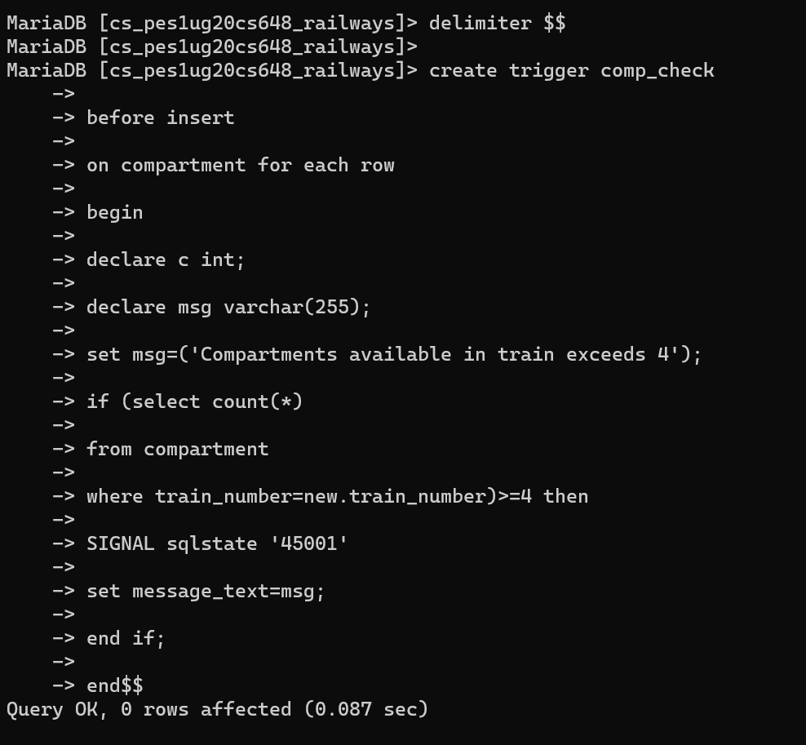

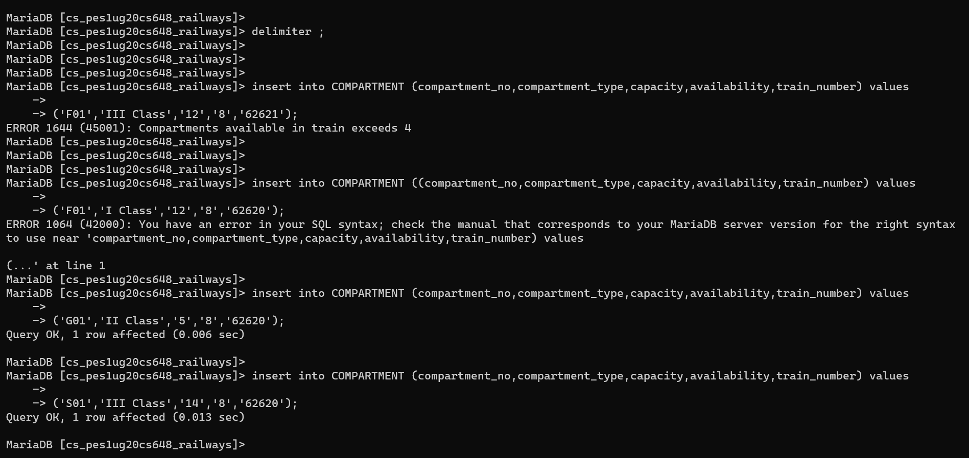

2) create a trigger to add payment information to the backup table when we try to delete some information from ticket table.

Create table payment_info_backup( transaction_no bigint NOT NULL,  
price int,  
                        card_no long,  
                        bank  varchar(255),  
                        pnr varchar(255),  
                        PRIMARY KEY(transaction_no));  
                          
set foreign_key_checks=0;  
  
delimiter $$  
create trigger payment_backup  
before delete  
on ticket for each row  
begin  
declare tn bigint;  
declare prc int;  
declare cn long;  
declare bnk varchar(255);  
declare pnr1 varchar(255);  
select * into tn,bnk,cn,prc,pnr1  
from payment_info   
where pnr=old.pnr;  
insert into payment_info_backup(Transaction_No,Bank,Card_No,Price,pnr)  
values (tn,bnk,cn,prc,pnr1);  
end$$  
delimiter ;  
  
delete from ticket where PNR='PNR005';  
select * from payment_info_backup;  
  
drop trigger payment_backup;  
drop table payment_info_backup;

